November 13th, 2011
Hi
Well, I duly went and voted last Sunday. But the pundits were a little wrong - a record of about 41.4% of the number of eligible voters turned out, though that it still not a high turnout rate, even excluding those who couldn't vote because the candidate in there area was elected unopposed. The candidate I voted for lost - badly - getting only about 600 of the 3400 or so votes cast! I do not have a good track record of electing winners. In the last election (for what, I cannot remember), the candidate I voted for, who was also the incumbent, lost. For these elections, I also found out why there were only two names on my ballot paper. The Yuen Long district council has 31 members, and the district is divided into 31 smaller areas with one person elected from each.
Nadine mentioned that she and Leonie are going to New York to open a HK bank account (?HSBC) in order to receive the HK$6000. But before you go, double check with your Boston branch (or even the main bank in NY) to ensure that you are indeed able to open a Hong Kong account to receive the $6000 in NY. It would be maddening to go all that may and find out it cannot be done.
Summer has now gone in HK. Temperatures dropped this week from a maximum of 29-30⁰C to 23⁰C yesterday. So I started my runs yesterday with the same run as usual, from Tai Po to lead mine pass, la oop around and up to Grassy Hill, then back through the forest to Tai Po (which L and T are familiar with though I stick entirely to the road rather than the track). I was expecting the time to be a few minutes slower and at exactly 2 hours, it was 7 minutes off my best, though not the slowest. I also finished swimming this past week to give 100 swims for the season at an average of 2.45 km/swim. This is the first time I have ever calculated the average for the swims.
I had another visit to the dermatologist (a different one - again!) the other day, the first visit for six months. Nothing too suspicious, so the next appointment will be in another 6 months.

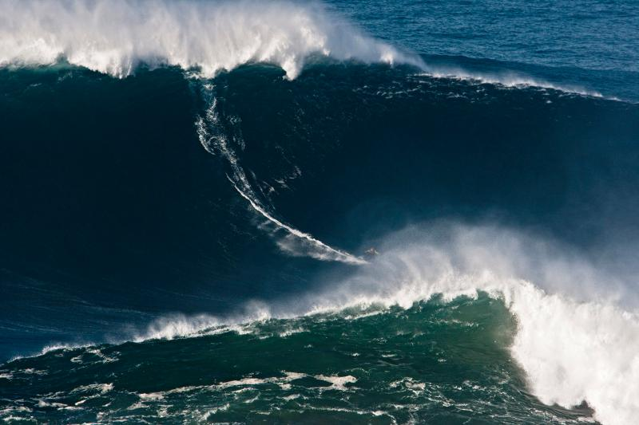
On Friday night, I went to the secondary school I taught at when I first came to HK for a 1971 Form 5 graduates reunion. There were 22 students and four teachers of this era there, some even coming from overseas! There was a buffet dinner (not very good) which is one reason why I expected my first run the next day to be slower (though it may not have been a factor).
Did you see the pic of the guy who set a world surfing record by riding a 90 foot wave in Portugal? Ninety feet - that's about the height of 10 storey building. Given the size of the wave, it was difficult to actually see the guy.
On the TV news, there have been clips of the APEC meetings in Honolulu. I think I saw Gavin, but that was probably wishful thinking. There do not seem to have been any riots. The locals are probably a more peaceful lot and Honolulu is probably a bit far away for rioters to travel to.
And talking of riots, or at least protests, there is a very interesting article on the Stanford e-mail site about the Occupy Wall Street movement. Have a look:
http://alumni.stanford.edu/get/page/blogs/post-view/?ciid=45773
Last week's Time magazine contained some interesting articles, including:
1. The search for pathogens in animals in the jungles (primarily Africa) that jump to humans to try to identify the next potential pandemic before it happens. AIDS of course is a disease in which a virus jumped from primates (where it did not cause much harm) to humans (who had no immunity to it). SARS and the swine flu are other examples. But of course, these three were only identified after the diseases had spread.
2. The dangers of red wine for women. Research shows that more than about 3 or so glasses a week increases the chance of breast cancer by 15%, while more ups the chances to 50%. Also, while resveratrol (the substance in red grapes) has health benefits, for some of these benefits, you need to drink 10 litres (about 2.5 gallons) a day to get enough resveratrol. So, why not just drink red grape juice to get the benefits but not the dangers.
3. The main article was about favouritism of children by their parents. I don't think we had any favourites, did we? As the article says, parents are sometimes unaware of this and when they are, they try to hide or deny it. What do you think - did you think of yourself as a favourite or were you, like Charles Dickens, a LFS (least favoured sibling)? I cannot link you to the article as you have to be a subscriber, but here is a video from the Time website:
http://www.time.com/time/video/player/0,32068,1174910082001_2094342,00.html
4. Gavin, you may be interested in the article / book review on Westmorland, the general who lost Vietnam (this one can be downloaded):
http://www.time.com/time/magazine/article/0,9171,2098599,00.html
Today is Remembrance Sunday and is also the 70th year from the Japanese invasion of HK in December 1941. In Commonwealth countries, (WWI) armistice day (November 11th.) is remembered on the Sunday nearest day to the 11th. In the US, it is on the 11th.
That’s it for now.
Cheers

